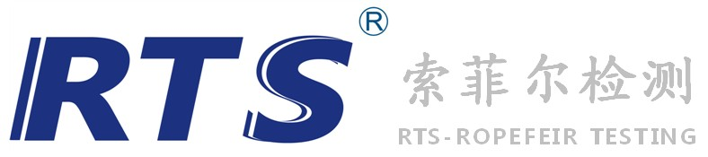
CPSIA TEST REQUEST FORM测试申请表格
Footwear鞋类 |  |  | Accessories & Gear 配件与工具 |  |  | Apparel服装 Toys 玩具
Applicant Name申请公司名称:  If the company title stated on the report is different from the applicant, Please clarify  如果显示在报告上的公司名称不同于申请公司,请注明：  Address 地址：  Contact Person 联系人： Department 部门： Postcode 邮编：  Telephone 电话： Fax 传真： E-mail 邮箱： |  |  |  |  |  | Official Use Only(内部填写)
 |  |  |  |  |  | Name (业务跟单姓名)
 |  |  |  |  |  | Rec. Date (收样日期)
 |  |  |  |  |  | Out Date (出单日期)
 |  |  |  |  |  | Order No. (报告编号) |  | SZD
 |  |  |  |  |  | Invoice No. (发票号)
Sample & Material Information 样品及材质资料
Sample Description 样品描述
Model name 款式
Article No 款号
Age Grade 合适年纪 Adults成人 Infants儿童，age年龄
Country of Origin来源地 |  |  |  | Country of Destination目的地
Factory工厂 |  |  |  | Buyer买家:
Test(s) Required 测试项目
total lead in paint ( 600ppm 90ppm others: )
total lead (600ppm 300ppm 100ppm others: )
small parts small part including abuse test
sharp points sharp points including abuse test
sharp edges sharp edges including abuse test
flammability (fabric /vinyl /children’s sleepwear(sizes 0-6x) /children’s sleepwear(sizes 7-14) /solids / others: )
label & document checking
∑Phthalates (3P 6P others: )
ASTM F963 (soluble heavy metal others )
formaldehyde
others
Test Components测试部位描述:
Service Required： Regular（常规） Express (加急：3 working days) Emergency (特急：1 working day) Same Day（当 天）
服务种类（如果可行） (5-6 working days) 〔40％Surcharge附加费〕 〔100％Surcharge附加费〕 〔150％Surcharge 附加费〕
Is This a Retest 是否为重测试： Yes是(Previous Report NO. 原报告号 ) No 否
Sample Return退样： Yes是 No否
Report Service： Fax 传真 Mail 邮件 Express 特快专递 Self pick-up 自取
Important Notes 重要提示：
- RTS Testing Organization has the full discretion in carrying out the test. (Including selection of appropriate test method(s) and SUB-contraction.) 深圳市索菲尔检测机构对测试有完全的判断权（包括选择适当的测试方法和分包）。
- Unless it is specified. All requested test(s) will be performed on the latest edition of the test method(s) which is determined by the laboratory.除非特别指定，实验室将使用测试方法的最新版本来完成所有测试。
- No comment may be given for the test items if related standard or specification is not available. 如无相关标准和说明，本公司将不对测试样品给予评价。
We request for the above test and agree that all testing will be carried out subject to RTS scale of charges as set forth in their price list of which we have seen a copy. 我们要求进行以上测试，并将依照RTS所制定的价目表来付费。
Date Authorized Signature & CompanyChop
日期： 申请人盖章及签名：

